Financial Lit Name: _______________________

______________ _____________

WS Assessment

Target 8:

loans

**I can:**

* Become familiar with types of lending institutions.
* Compute finance charges for installment
* Compute monthly payments using a formula, compute finance charges on loans.
* Calculate the present value of a single deposit investment, of a periodic deposit investment.

**Unit 4 Math Topics:**

* Cubic regression
* Exponential growth and decay
* Linear equations and inequalities
* Linear regression
* Measures of central tendency
* Natural logarithm, base e
* Percent
* Quadratic regression
* Spreadsheets and formulas

If you purchase something that you do not pay for immediately, you are using **credit**.

People who use credit are called **debtors**. Organizations or people that extend credit to

consumers are called **creditors**. Any type of credit is based on honesty. Creditors need to be sure that

they will be paid back before they extend credit. They will have you fill out an application for credit and will check your financial history. This history includes three basic items.

**Assets** (everything you own: home, car, bank accounts, …) **Earning power** (your ability to earn money now and in the future) and a **Credit rating** (your credit’s report card)

A credit reporting agency compiles records on all users of credit. These records are used by creditors before they issue credit to a consumer. The best way to start a good credit history is to open savings and checking accounts, pay all your bills on time, and successfully handle all your credit transactions. The FICO score range from 300 to about 850, summarize the probability that debtors will repay their debts. A higher score indicates a better credit rating. A person with a score near 800 is less of a risk to a

creditor than a person with a score near 500.

Some stores offer creditworthy customers the convenience of paying for merchandise or services over a period of time. This is an **installment plan**. The customer pays part of the selling price at the time of purchase called **down payment**. The scheduled payments are usually made on a monthly basis. Installment buyers are charged a fee. This fee is the **interest**, or **finance charge**, and is added to

the cost.

Heather wants to purchase an electric guitar. The price of the guitar with tax is $2,240. The installment plan requires a 15% down payment. The remainder, plus an additional finance charge, is paid back on a monthly basis for the next two years. The monthly payment is $88.75. What is the finance charge?

Assume the original price of the guitar was p dollars, and Heather made a 20% down payment for a one-year installment purchase. The monthly payment was w dollars. Express the finance charge algebraically.

Create a spreadsheet to implement the formula to find missing letter info from f 🡪 v. Stamp

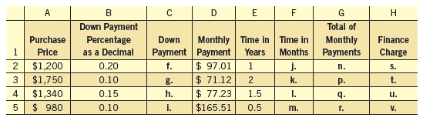

A **layaway** plan is similar to an **installment** plan, but the customer does not receive the merchandise until it is paid for. It is held in the store for a fee. If you purchased a $1,700 set of golf clubs on a

nine-month layaway plan and had to pay a monthly payment of $201, what is the sum of the monthly payments? What was the fee charged for the layaway plan?

A **deferred payment** plan is also similar to an installment plan, except there are very low monthly payments until the end of the agreement. At that point, the entire purchase must be paid in full.

If it is not paid, there will be high finance charges. Often, there is no interest; stores use no-interest deferred payment plans to attract customers. Many times there is also no down payment.

Chris purchases a living room furniture set for $4,345 from Halloran Gallery. She has a one-year, no interest, no money down, deferred payment plan. She does have to make a $15 monthly payment for the first 11 months. How much must Chris pay in the last month of this plan?

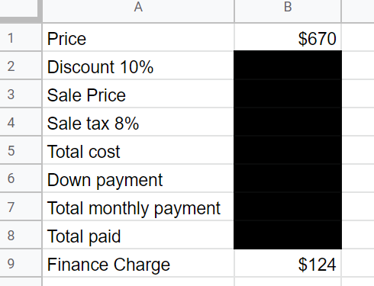Lillian purchased a guitar from Smash Music Stores. It regularly sold for $670, but was on sale at 10% off. She paid 8% tax. She bought it on the installment plan and paid 15% of the total cost with tax as a down payment. Her monthly payments were $58 per month for one year.

a. What is the discount?

b. What is the sale price?

c. What is the sales tax?

d. What is the total cost of the guitar? \

e. What is the down payment?

f. What is the total of the monthly payments?

g. What is the total she paid for the guitar on the installment plan?

h. What is the finance charge? Redo by spreadsheet. Stamp

Organizations that extend loans are called **lending institutions.** There are many types of lending institutions. **Banks**: Most consumers apply for loans at banks. Require a good credit rating.

**Credit Unions** provides financial services for its members only usually at an interest rate that is lower than a bank can offer. **Consumer Finance Companies** These businesses primarily lend money to people with poor credit ratings, who cannot get a loan anywhere else. High interest are charged rates for this service. **Life Insurance** make loans to their policyholders, the interest rate is good because the life insurance company is not taking a tremendous risk because if the loan is not paid back, it can be deducted from the life insurance benefit when it is paid. **Pawnshops** are known for small, quick loans. A customer who needs money leaves a personal belonging, called collateral, with the pawn broker in exchange for the loan. When the debtor returns with the principal plus interest, the collateral is returned.

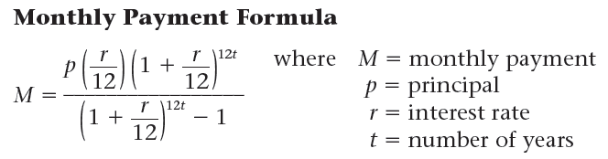

Mark bought a new car. The total amount he needs to borrow is $28,716. He plans on taking out a 4-year loan at an APR of 5.12%. What is the monthly payment? $662.87

Bart needs to borrow $7,000 from a local bank. He compares the monthly payments for a 9.75% loan for three different periods of time. What is the monthly payment for a one-year loan? a three-year loan?

five-year loan? Which is better?

Fill the missing letter info using spreadsheet. Stamp

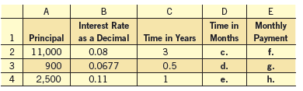

Determine the total interest owed on a 5-year $10,000 loan at 6% APR.

Hannah is taking out a 4.3% loan to purchase an $18,000 car. The length of the loan is 8 years. How much will she pay in interest?

Claude wants to borrow $25,000 to purchase a car. After looking at his monthly budget, he realizes that all he can afford to pay per month is $300. The bank is offering a 5.9% loan. What would need to be the length of his loan be so that he can stay within his budget?

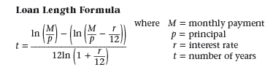

What impact would an increase in the monthly payment of $50 have on the length of the loan?

A loan calculator for a $100,000 loan with an APR of 7.5% for a period of 15 years, taken out in January 2010.

Monthly payment amount:

The yearly loan balance is as follow

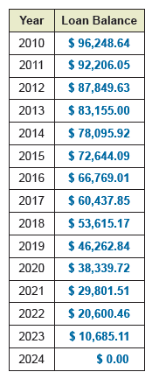

Create a scatter plot for this in desmos then start to find the regression formula that fit the data

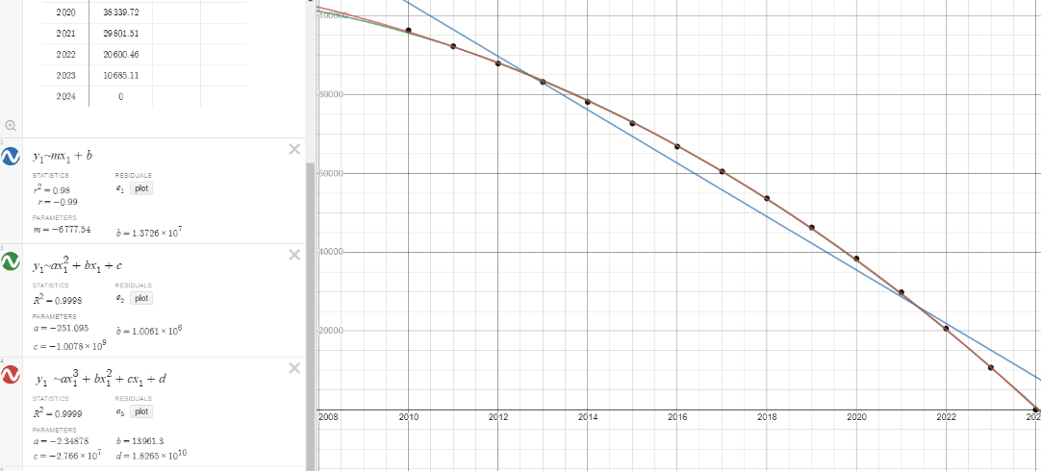

Redo it with spreadsheet on google docs for stamp

**Assessment Target 8**

**I can…** calculate monthly payment and finance charge

What is the total interest on a ten-year 6.1% loan with a principal of $32,000?

Devon is considering taking out a $7,000 loan. He went to two banks. Stevenson Trust Company offered him an 8-year loan with an interest rate of 8.6%. First National Bank offered him a 5-year loan

with an interest rate of 10%. Which loan will have the lower interest over its lifetime?

Jennifer wants to borrow $20,000. Her bank offers a 7.1% interest rate. She can afford $500 a month for loan payments. What should be the length of her loan to the nearest tenth of a year?

Given the yearly payment schedule as below

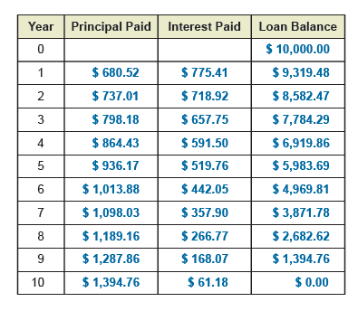

What is the loan amount?

What is the length of the loan?

What is the monthly payment?

Construct a scatterplot using the data points (year, loan balance)

Stamp

Write regression equation that approximates the year/loan balance relationship

Linear Quadratic Cubic